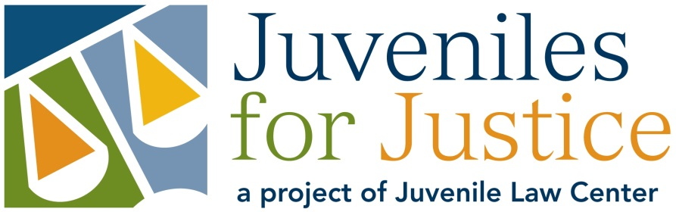
Have you been involved with the juvenile justice system?
Do you want to make the system better?
Do you want your voice to be heard?
Become a Youth Advocate with Juveniles for Justice!
What is Juveniles for Justice (J4J)? J4J is a group of young people who have been involved with the juvenile justice system and work together to create change that improves the lives of youth who have been in the system.

What does J4J do? Each year, Youth Advocates learn about the juvenile justice system and, based on this information and their own experiences, create a project to improve the system. As part of their campaign, Youth Advocates present their experiences, opinions, and project to different juvenile justice officials and workers such as judges, lawyers, probation officers, and policymakers to promote their ideas for change.

How often do Youth Advocates meet? Youth Advocates meet once a week from September to June. Sessions last 2 hours. Youth Advocates are required to attend and participate in each session.

Are Youth Advocates paid? Yes. Youth are paid for each session and receive stipends for additional work.

How do I become a Youth Advocate? Fill out the application and drop it off or mail it to Cathy Chezik, Juvenile Law Center, 1315 Walnut Street, 4th Floor, Philadelphia, PA 19107. You can also email your application to cmoffa@jlc.org or fax it to 215-625-2808.

**Final Deadline: Applications are due on August 31th**

Please contact Cathy Moffa at cmoffa@jlc.org or 215-625-0551 for more information.
Please note that you must have been involved in the juvenile justice system in order to apply.

Youth Advocate Application
**Final Deadline: August 31th**

Name: ____________________________________________ Age: ___________
Phone number(s) where we can reach you: _________________________________
____________________________________________________________________
Address: _____________________________________________________________

Are you currently attending school? Yes No
If yes, where? _________________________________________________________

Are you currently working? Yes No
If yes, where? _________________________________________________________

- Have you ever been involved with the juvenile justice system? Please note that all Juveniles for Justice members must have experience with the juvenile justice system.

Yes No

- Why do you want to be in Juveniles for Justice (J4J)?

- Is there a specific issue or problem in the juvenile justice system that is important to you or interests you?

- Please circle which topic you would be more interested in working on:

- Making sure discipline in juvenile justice facilities is fair and supportive (and not harmful or violent)
- Ensuring youth who have been in the juvenile justice system are able to pursue higher education after high school

- This year we might focus on the issue of education for youth involved in the juvenile justice system. What do you think are the biggest problems when it comes to education for youth in the juvenile justice system?

- Do you have any leadership or public speaking experience? If so, please explain in complete sentences.

- Do you have any work, volunteer, or extracurricular experience? If so, please explain in complete sentences.

- Is there anything else you would like us to know?

Please circle ALL of the times and days of the week that you are available to meet for J4J workshops:

MONDAYS: | 1-2pm | 2-3pm | 3-4pm | 4-5pm | 5-6pm | 6-7pm
TUESDAYS: | 1-2pm | 2-3pm | 3-4pm | 4-5pm | 5-6pm | 6-7pm
WEDNESDAYS: | 1-2pm | 2-3pm | 3-4pm | 4-5pm | 5-6pm | 6-7pm
THURSDAYS: | 1-2pm | 2-3pm | 3-4pm | 4-5pm | 5-6pm | 6-7pm
FRIDAYS: | 1-2pm | 2-3pm | 3-4pm | 4-5pm | 5-6pm | 6-7pm

Submit applications to: Cathy Moffa at Juvenile Law Center by e-mail (cmoffa@jlc.org), fax (215-625-2808), or mail/in person (Juvenile Law Center, 1315 Walnut Street, 4th Floor, Philadelphia, PA 19107).

Applications are due August 31th.

